# **Transfer Files By Using WinSCP**

**Steps To Transfer To Linux From Windows By Using WinSCP:**

1. Download WinSCP from <https://winscp.net/eng/download.php>

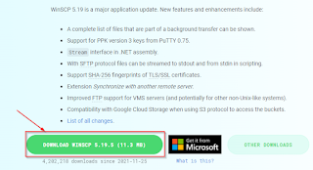

1. Install WinSCP. After finish, just launch the application.

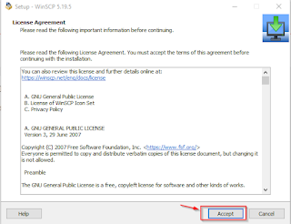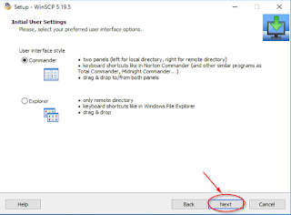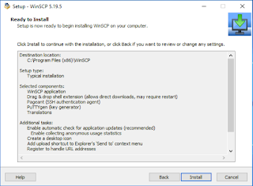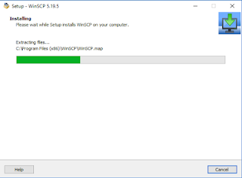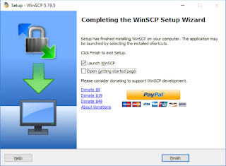

1. In the Host Name field, enter the IP address of your Linux Server. In the port field, make sure that it is 22. Choose SFTP for File protocol type. In User name and Password field, enter your credential.

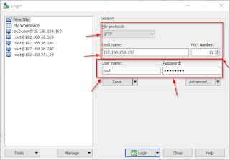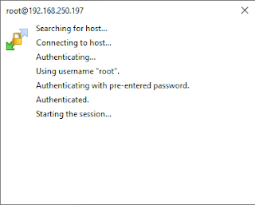

1. If you have entered the correct root password, WinSCP will show the available folder inside the Linux server. The left side is your Windows side and the right side is your Linux side.

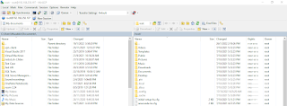

1. To start transferring, choose one or more files from the Windows side and drag them to any folder you want into the Linux side.



**Steps To Transfer To Windows From Linux By Using WinSCP:**

1. In the Host Name field, enter the IP address of your Linux Server. In the port field, make sure that it is 22. Choose SFTP for File protocol type. In User name and Password field, enter your credential.



1. If you have entered the correct root password, WinSCP will show the available folder inside the Linux server. The left side is your Windows side and the right side is your Linux side.



1. To start transferring, choose one or more files from the Linux side and drag them to any folder you want into the Windows side.

